Practical exercise for Custom package

Exercise 1: Create a Simple Package
Objective: Create a custom package with modules for math operations and string manipulations.
Instructions:
- Create a Directory: Create a directory named my_package.
- Add an __init__.py File: Create an empty __init__.py file in the my_package directory.
- Create a Module for Math Operations:
  - Create a file named math_utils.py in the my_package directory.
  - Define two functions in math_utils.py: add(a, b) and subtract(a, b).
Create a Module for String Manipulations:
- Create a file named string_utils.py in the my_package directory.
- Define two functions in string_utils.py: capitalise_words(text) and reverse_string(text).
Use the Package:
- Create a new Python script or Jupyter notebook.
- Import and use the custom package modules to perform operations.

Exercise 2: Expand the Package
Objective: Extend the custom package by adding more functionality and demonstrate importing specific functions.
Instructions:
- Add a New Function in math_utils.py:
- Add a function named multiply(a, b).
- Add a New Function in string_utils.py:
- Add a function named lowercase(text).
- Use the Extended Package:
- Modify the Python script or Jupyter notebook to import specific functions and use the new functionality.

Exercise 3: Creating a Custom Package for Data Analysis
Objective
The exercise will enable you to learn about the creation, structure, and usage of a custom package named data_analysis, which includes modules for data loading, data cleaning, and data visualisation.
A) Create the Package Directory and Files.
Create a custom package named data_analysis with the following structure:
data_analysis: The main package directory.
- __init__.py: To initialise the package.
- load.py: Module for loading data.
- clean.py: Module for cleaning data.
- visualise.py: Module for visualising data.
B) Implement the Modules
- Implement functions to load data from CSV files. (load.py).
- Implement functions to clean the data (clean.py).
- Implement functions to visualise the data (visualise.py).

C) Use the Package
Create a separate script (main.py) to use the data_analysis package and run the script main.py

Exercise 3 solution:
A)
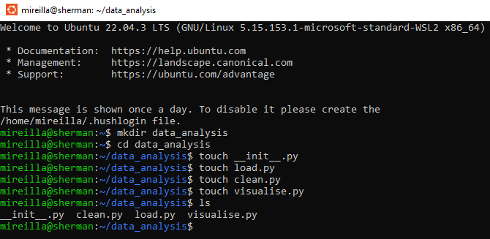

B) I could edit each of the files using the nano command. However, I have opened my .py files in Spyder to edit them (you can use any Python IDE). Remember how to access your package from the previous exercise.
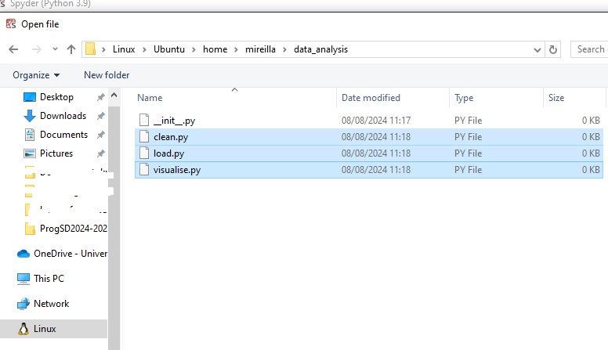

C) Implement functions to clean the data (clean.py). Edit the clean.py file to ensure that any missing data is dropped, and data is normalised. Normalisation is a preprocessing step that scales the values of a column to have a mean of 0 and a standard deviation of 1. This process is often used in data analysis and machine learning to ensure that different features contribute equally to the analysis.
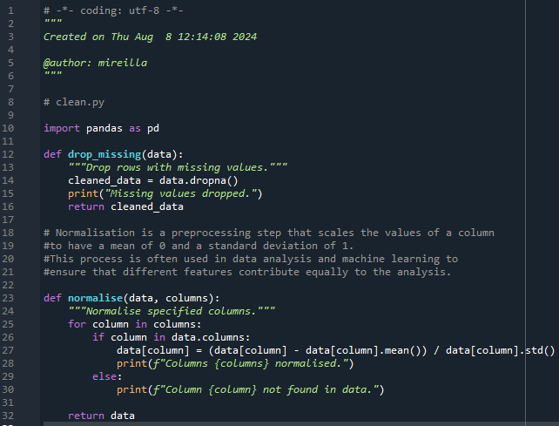

D) Implement functions to load data from CSV files (load.py). Edit load.py to load the data from the CSV file.
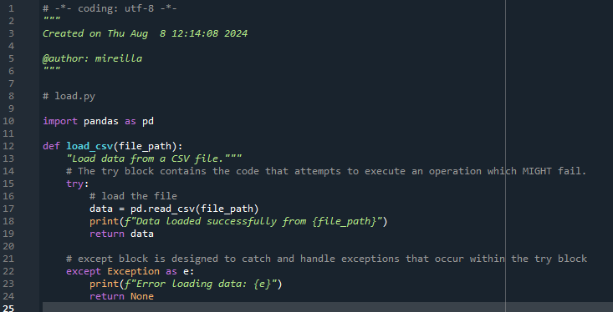
E) Implement functions to visualise the data (visualise.py). Edit visualise.py
- import matplotlib.pyplot and seaborn.
- Create a function for histogram.
- Create a function for a scatter plot.
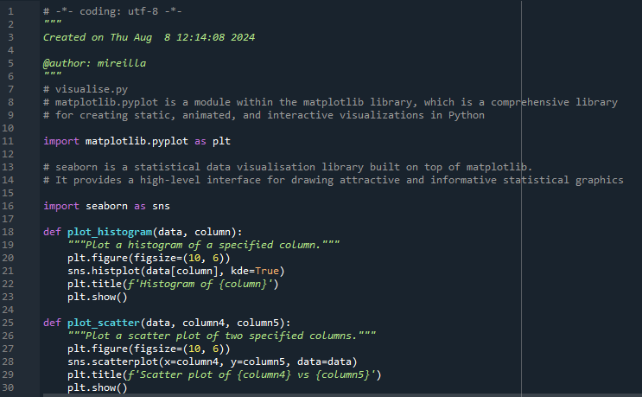
F) Create your main.py file using the touch command in Linux or directly from your Python IDE. Make sure it is saved in the same location as the other files. In main.py:
- Add the path to the custom data_analysis package
- Import the custom package modules
- Load the data (you can use this file).
- Clean the data (call clean.py).
- Visualise the data that is not normalised.
- Normalise the data (call clean.py)
- Visualise the normalised data (call visualise.py).
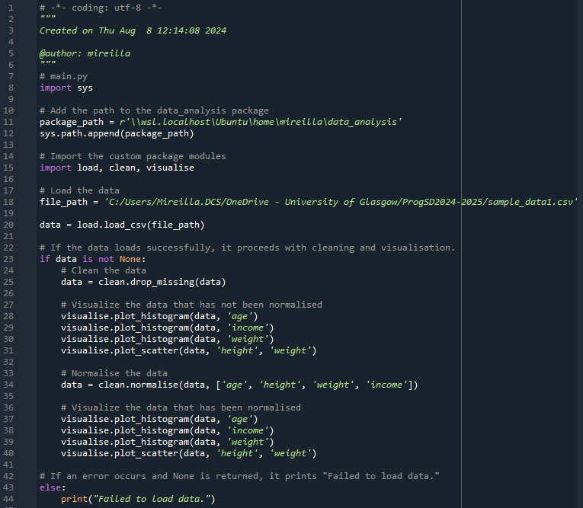

E)Outputs

Visualise without/with normalisation
Without Normalisation | With Normalisation
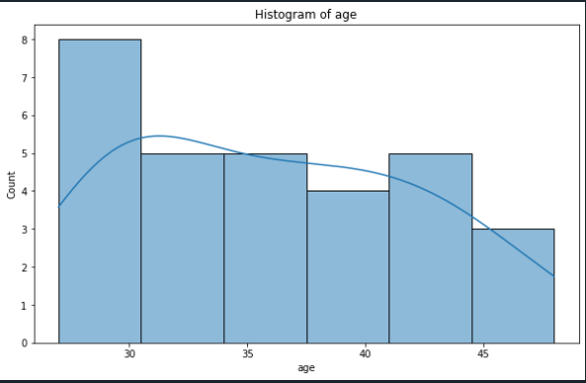 | 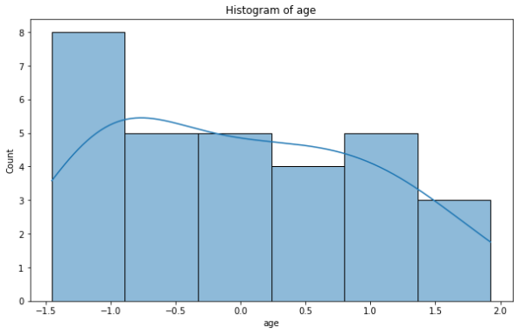
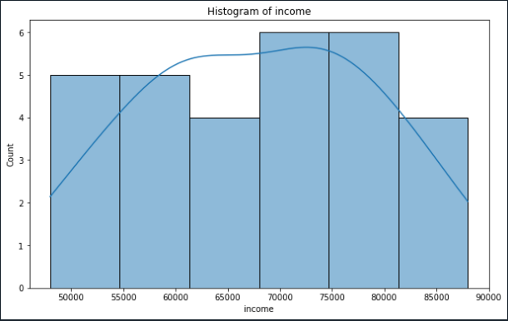 | 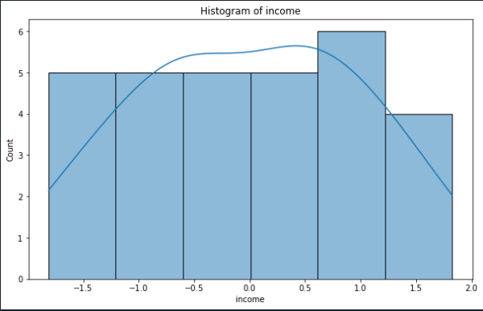
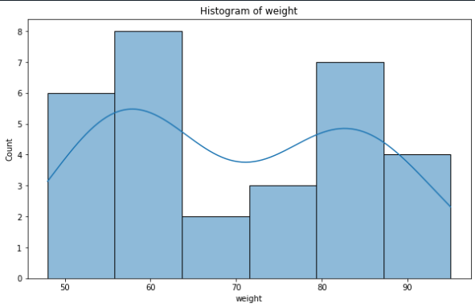 | 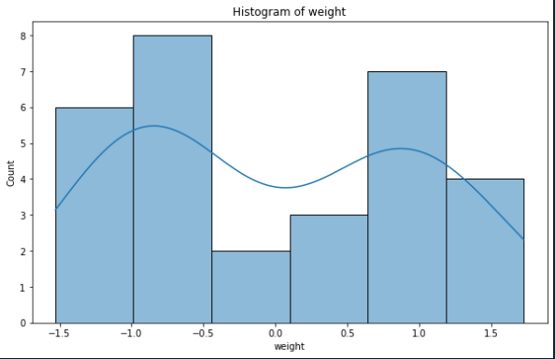
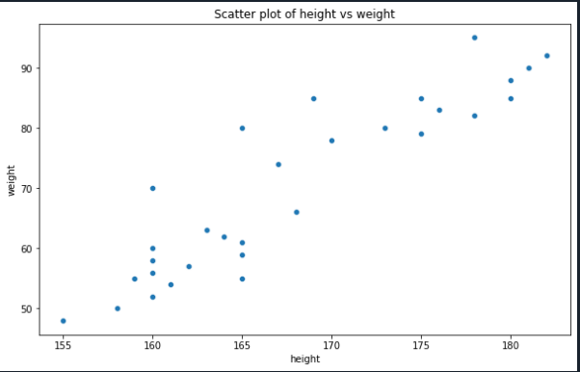 | 